**Responsive Web design**

**Assignment 2**

**COIT20268 , Term2, 2019**

**Assessment item – Assignment 2**

**Lecturer: Tom Marotta**

**Tutor: Tom Marotta**

**Prepared by:**

**Name : Aman Kumar Maharjan**

**Student Number : 12102452**

Contents

Portfolio 2.1 3

Standard size 3

Home Page 3

Category page 5

Detail Page 6

Mobile 7

Home Page 7

Category 9

Detail Page 11

Portfolio 2.2 13

Color Theory 13

Styling Images 13

Banners & Button colours 14

Table colours: 14

Text color 15

Link Color 15

Portfolio 2.3 17

Flowchart 17

Navigation in standard screen: 17

Navigation in small screen 17

Internal Navigation 19

Portfolio 2.4 21

Portfolio 2.5 23

Portfolio 2.6 26

Review and Testing 26

Assumptions 26

Summary 27

# Portfolio 2.1

Whole website has been redesigned to adopt the flexible layout. Responsiveness will be added on the design by replacing width with percentage. The new layout design and the mock-up of the web pages are demonstrated below.

## Standard size

The standard screen size is between 1024x768 to 1280x1024 for the website. However, the site will support standard layout from 501 px to 1024px. The following sections discusses about different webpages in standard size.

### Home Page

The homepage consists of standard header, content and footer section. In the header section, it contains logo and the navigation bar. In the content section, welcome message and the floor plan will be around the same horizontal layout and footer will be in the end. The whole page will support responsive layout.

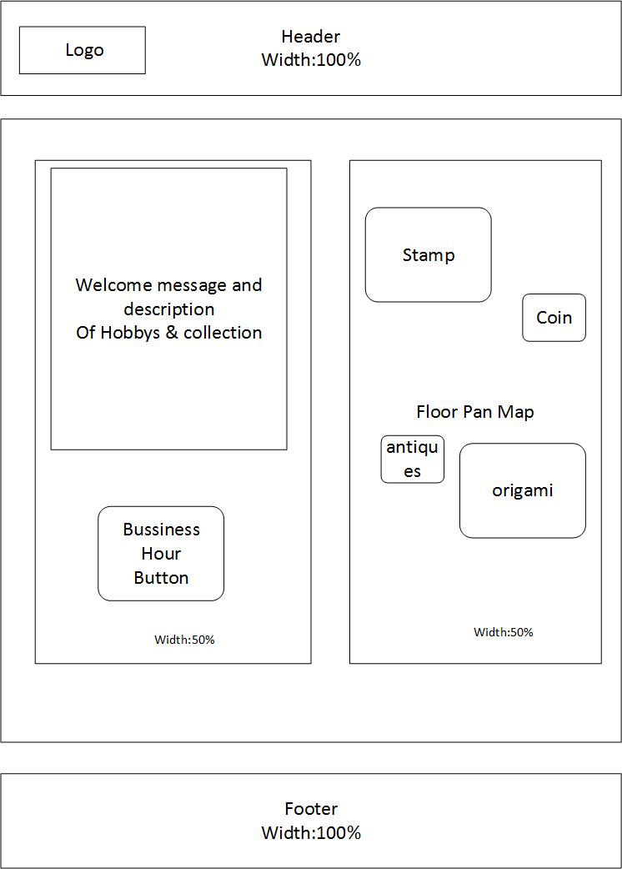

Fig:1 Layout of Homepage

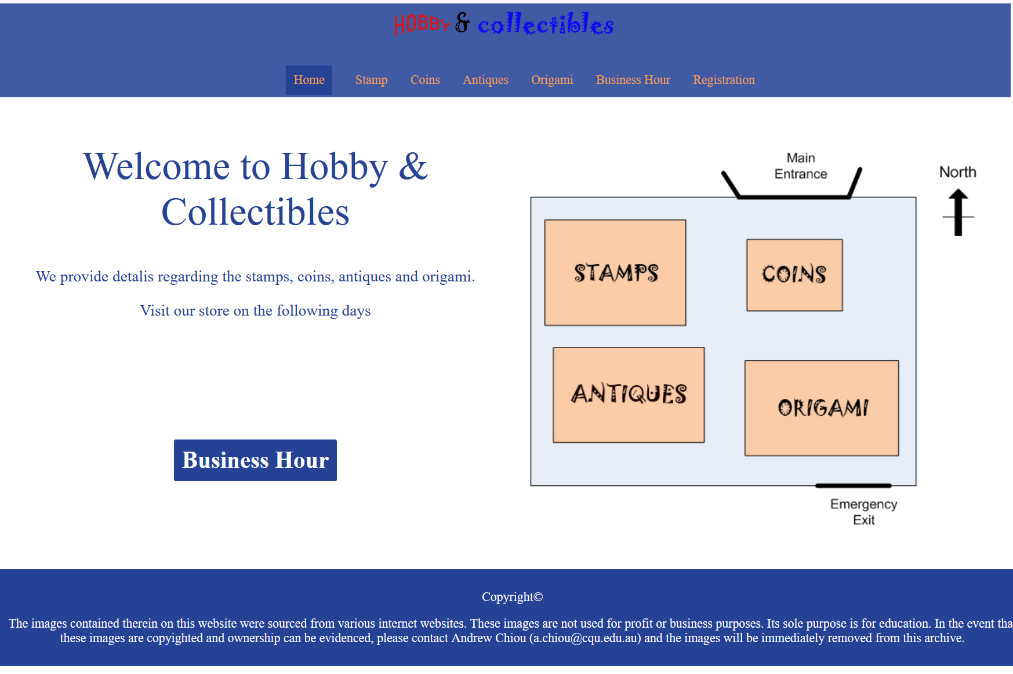

Fig:2 Mock-up of home page in standard size 1024x768

### Category page

The category page will list out the category of the different items. It will have header, footer and the product lists.

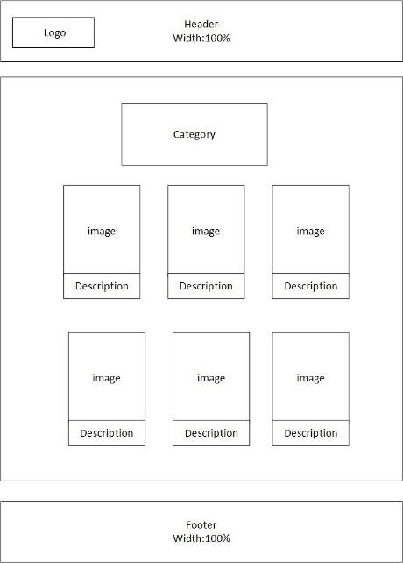

Fig:3 Flexible layout of category in standard size

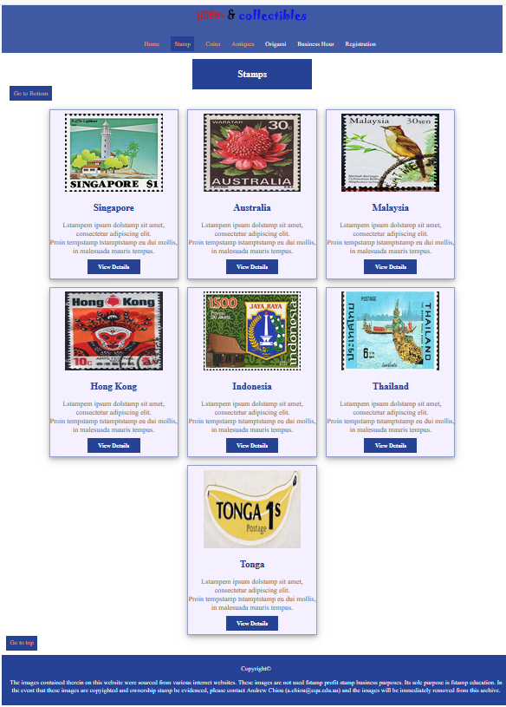

Fig:4 Mock-up of category in standard size

### Detail Page

The product detail page will contain the title and image surrounded by the text.

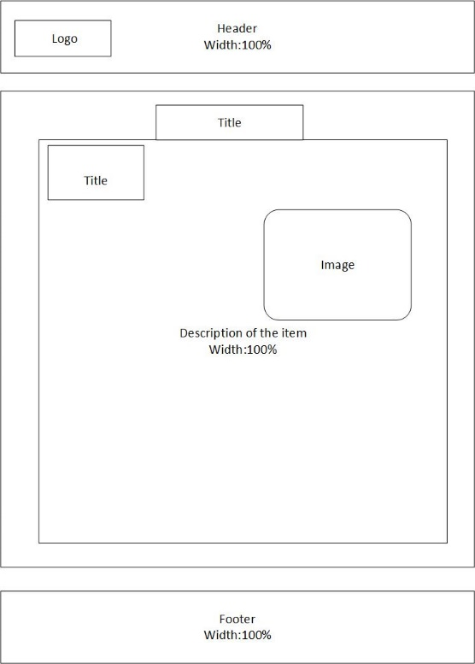

Fig:5 Flexible layout of detail in standard size

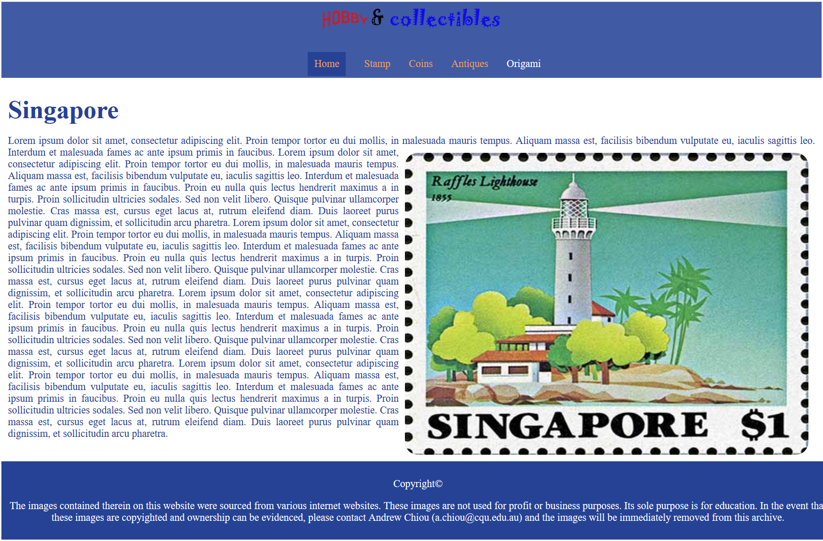

Fig:6 Flexible layout of detail in standard size

## Mobile

The mobile view of the webpage starts at 500x720 pixels. We could view the following flexible layout structures on the mobile view.

### Home Page

In mobile view, the floor plan image will be on the vertical structure as shown in the layout.

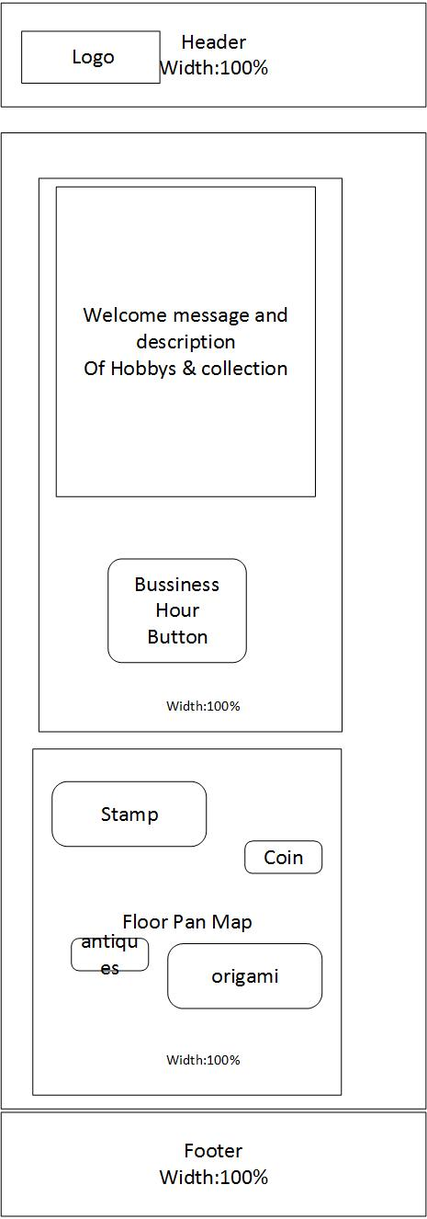

Fig:7 Flexible layout of home page in Mobile view

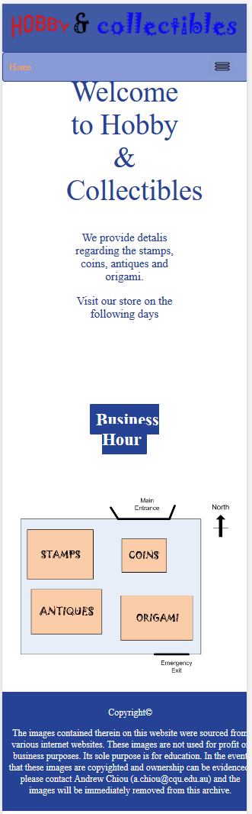

Fig:8 Mock-up of homepage in mobile size

### Category

The mobile view of the category will list down the product and its image one by one as shown in the layout diagram

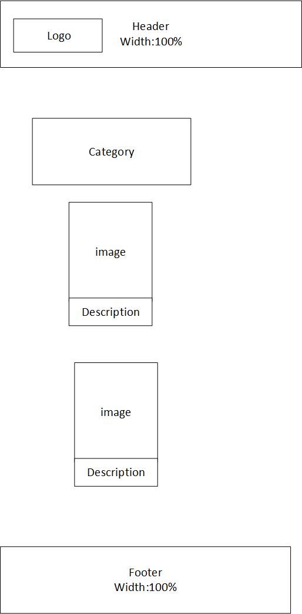

Fig:9 Flexible layout of category in mobile

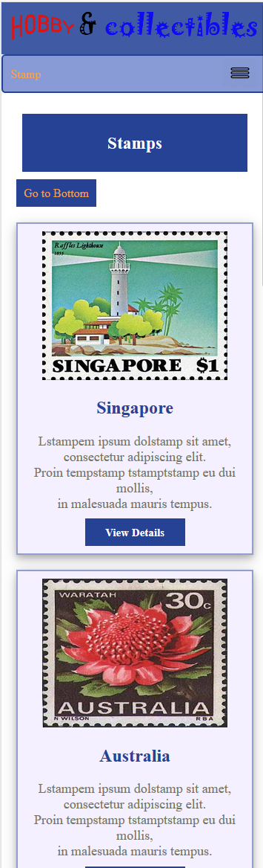

Fig:10 Mock-up of category in mobile view

### Detail Page

The detail page consists of the title, image and the description on the sequence.

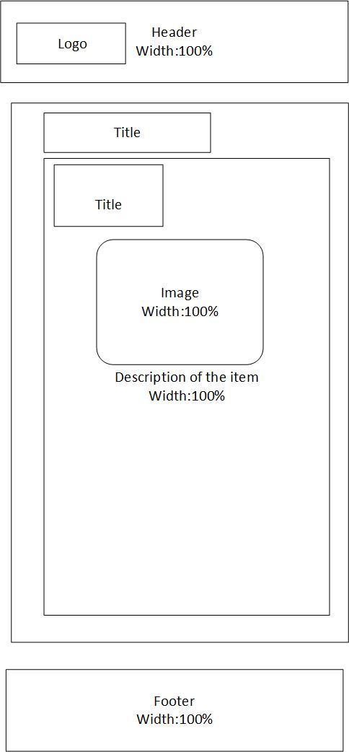

Fig:11 Flexible layout of detail in mobile view

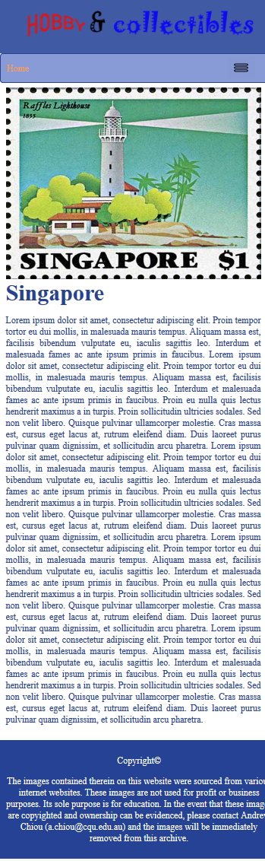

Fig:12 Mock-up of detail in mobile view

# Portfolio 2.2

## Color Theory

In the website, the triadic colour pattern will be used. Blue is the primary colour chosen. The different shades of blue and the orange will be applied on the different elements of the webpages.

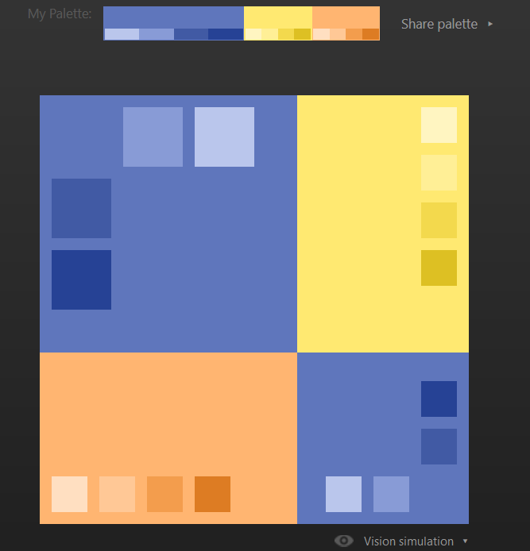

Fig:13 Triadic colour

## Styling Images

Image element will be used to display the images. It will have the alt attribute to show alternate text for an image, src attribute for the source of the image and width attribute for specifying the size of image. Detail webpage image will have the rounded edge corner.



Fig:14 Image in product

## Banners & Button colours

The primary colour dark blue will be applied on the background of the banners and the button. The banners are of header and footer. The text in the button will have the white colour.

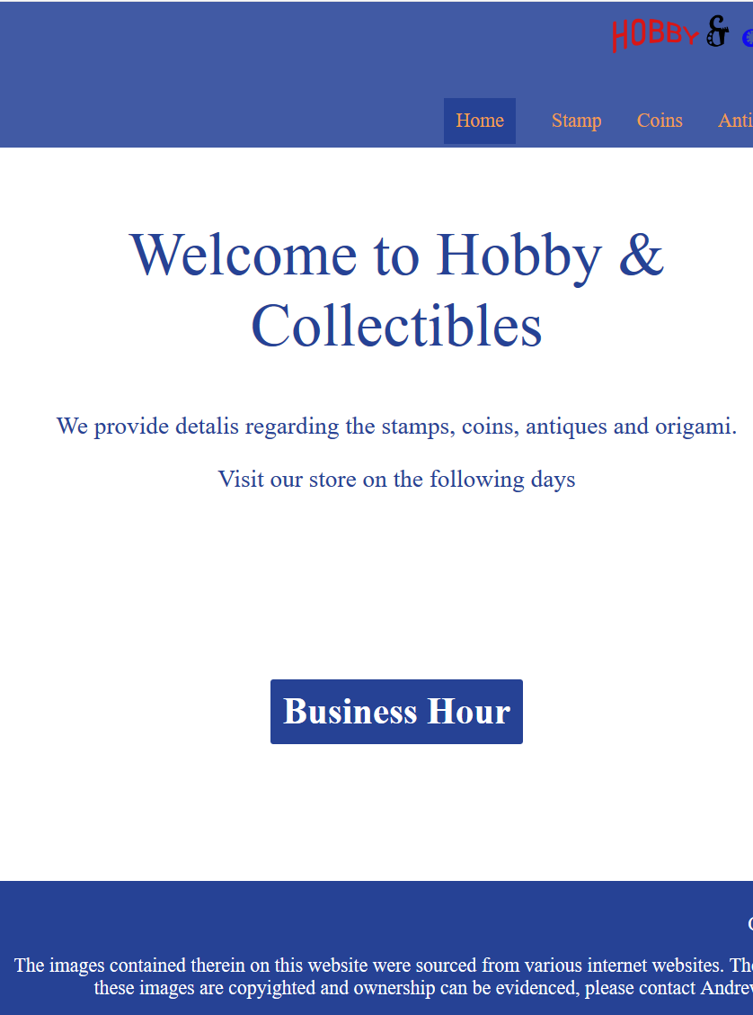

Fig:15 Button in home page

## Table colours:

In table, the primary color blue will be applied on the caption background and the opening days. While on the closing days, the organge color will be applied. Similarly, the heading of the table will be blue text with blue shade background.

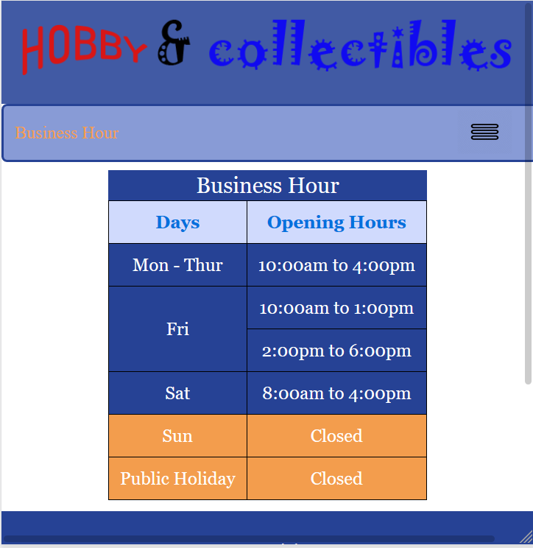

Fig:16 Table

## Text color

The default colour for text will be primary colour i.e. dark blue. However, different shades of blue and orange will be applied in different sections as per the requirement. In the navigation and button, white will be used. In the welcome message of the home page, blue will be used.

## Link Color

The default color for the link in will be white with no background. Dark blue background colour will be used to represent the current active link. On hover, the link will have light orange background. The visited links will be highlighted by orange colour.

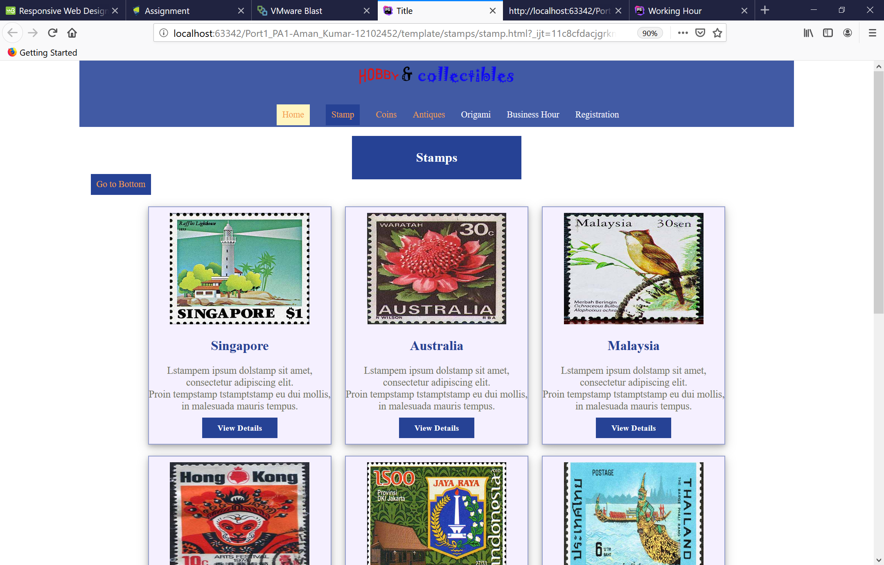

Fig:17 Navigation link in desktop site

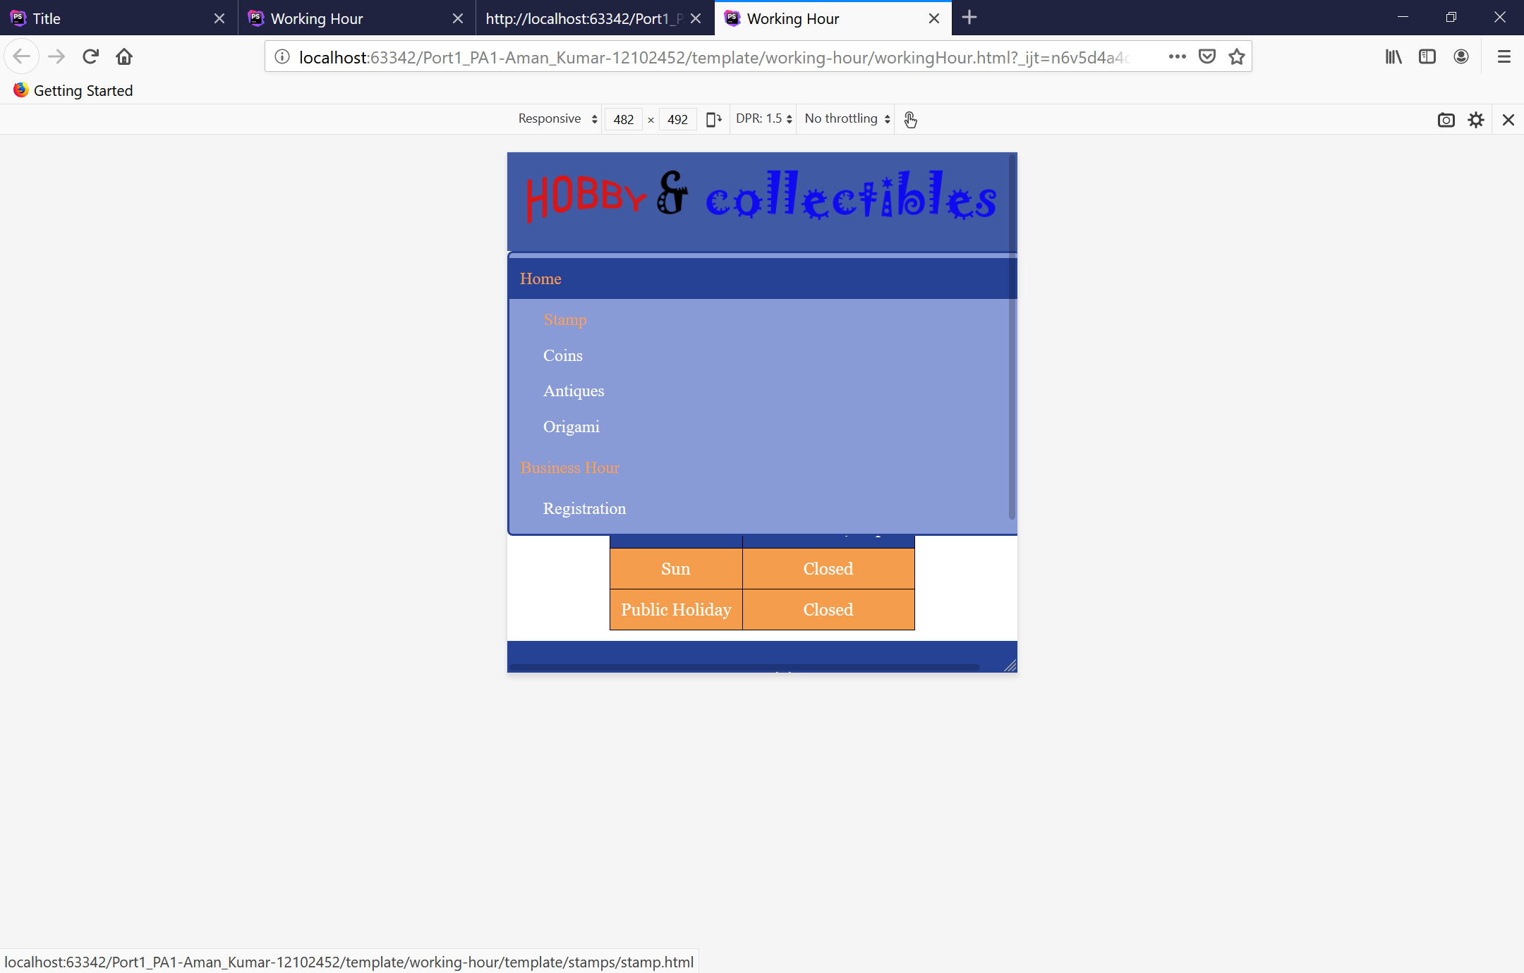

Fig:18 Navigation link in mobile site

# Portfolio 2.3

## Flowchart

Flowchart is created for identifying the possible links of navigation of the website. Then, it is applied to create the navigation menu and establishing links between the pages .

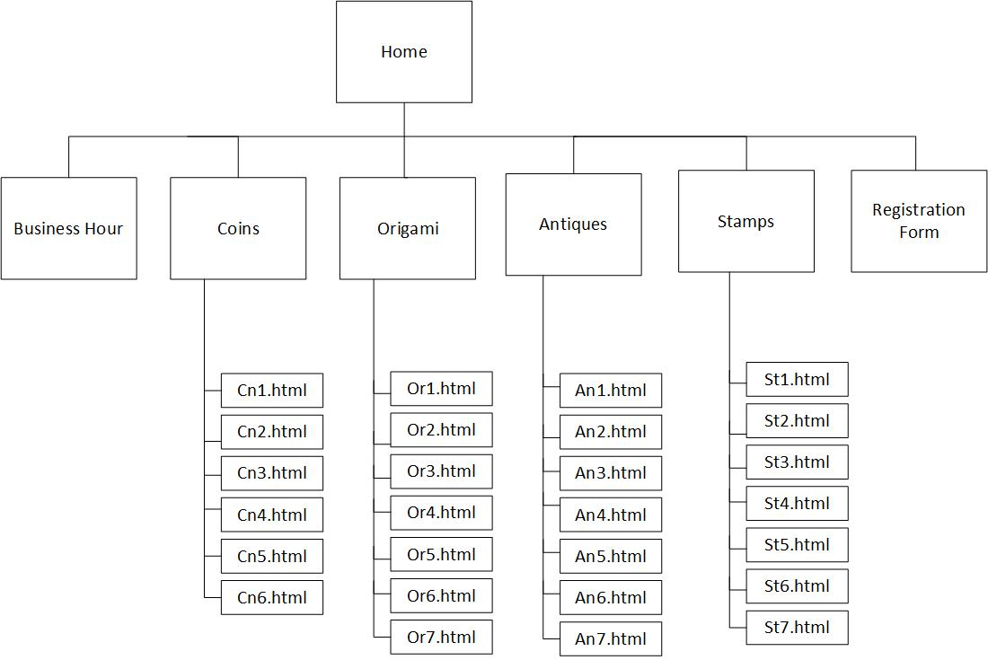

Fig:19 Flowchart of website

## Navigation in standard screen:

A horizontal navigation menu will be created for the large screen devices like tablets, desktop and laptops. This will allow user to easily navigate around the different webpages of the site.



Fig:20 Navigation link in desktop site

## Navigation in small screen

For the small screen device like mobile, the vertical navigation menu will be applied. The vertical navigation menu will be drop down menu, listing all the navigation links.



Fig:21 Navigation menu in mobile site

## Internal Navigation



Fig:22 Internal Navigation link in desktop site

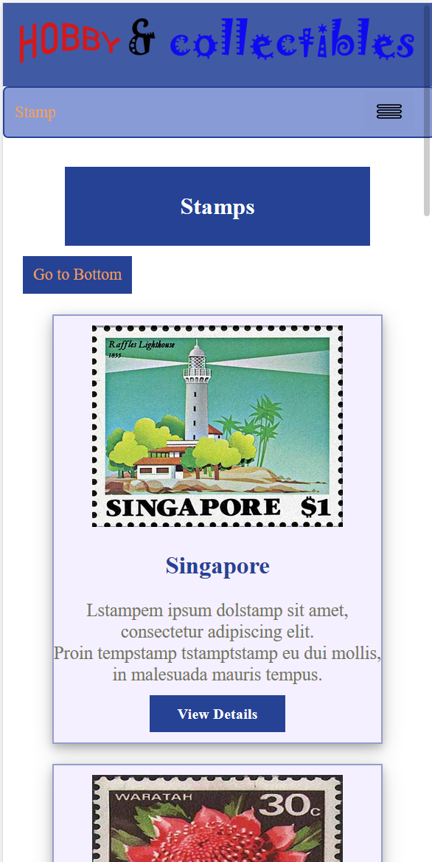

Fig:23 Internal Navigation link in mobile site

# Portfolio 2.4

The business hour data are displayed using the table format. The table element is used to present the days and opening hours data in each row and column chronologically. The table caption “Business Hour” is provided in the top of the table. Each of opening and closing hours has been marked with the separate colour. Next, the border and outlines are also provided for the better visibility of the content. The table supports responsive feature. Blue and orange colour shades are applied in different sections of the table.

**Large Display**

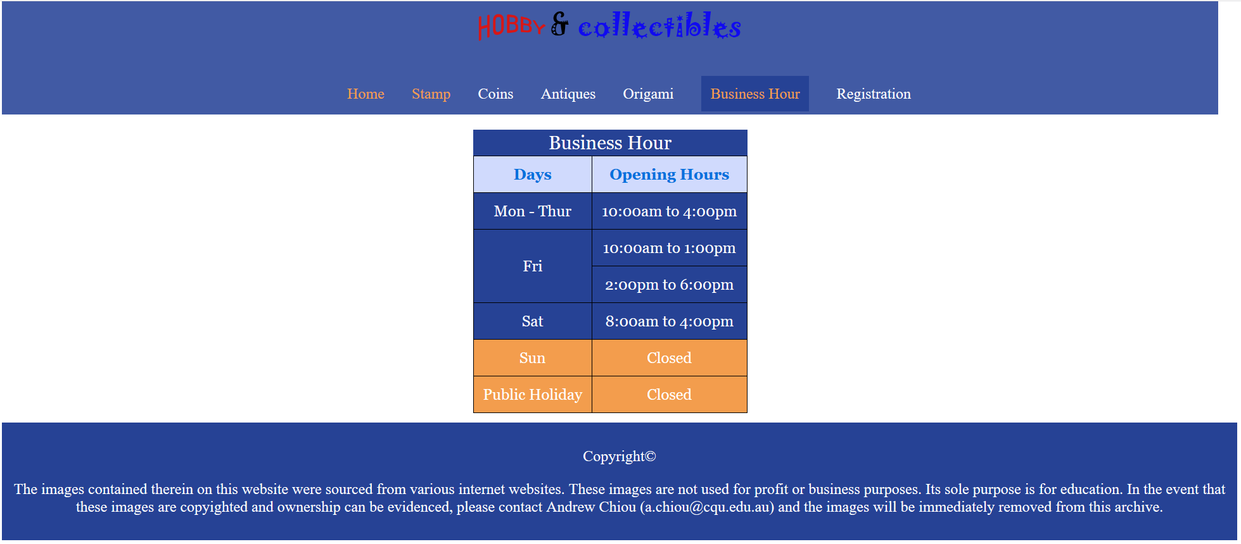

Fig:24 Business hour table in large display

**Mobile view**

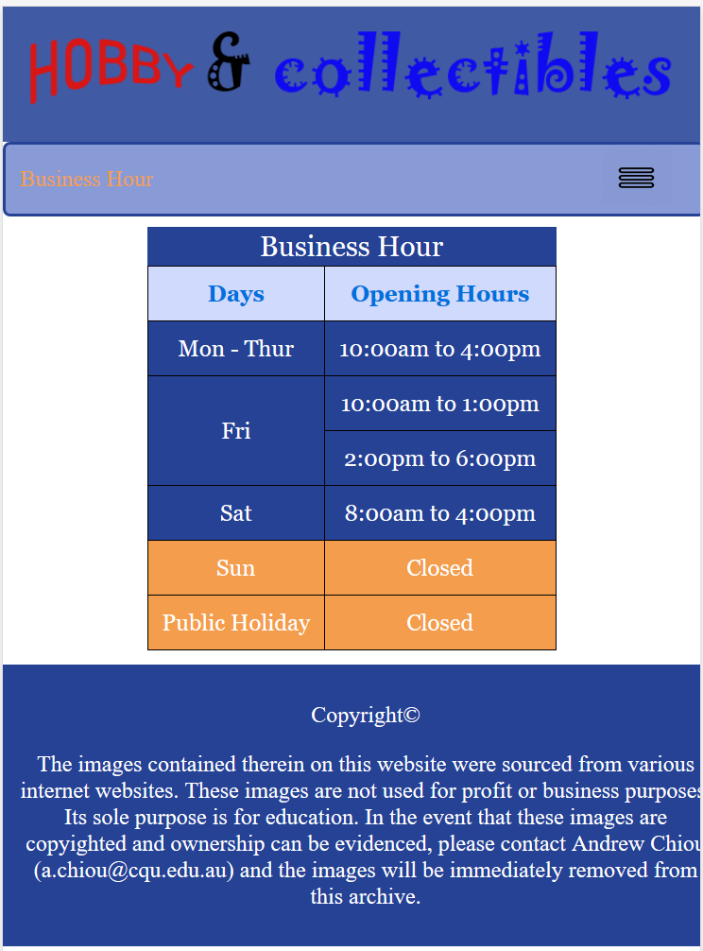

Fig:25 Business hour in mobile portrait view

**Landscape view**

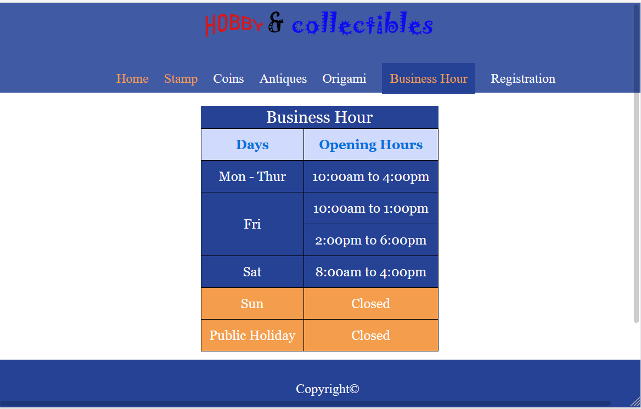

Fig:26 Business hour in mobile landscape view

# Portfolio 2.5

Contact form for hobbies and collection is added for the purpose of gathering the contact details of visitors in website. Form element is used for creating the contact form. It includes three different level of information i.e. Contact information, Areas of interest and Comments. The contact information consists of input types for name, email phone, nationality, age and gender. Areas of interest consists of check box lists, while comment consists of text area. In the bottom, submit and clear button are provided to submit the information and resetting form respectively. Form is responsive and supports high legibility in both kind of devices.

**Form view in large screen**

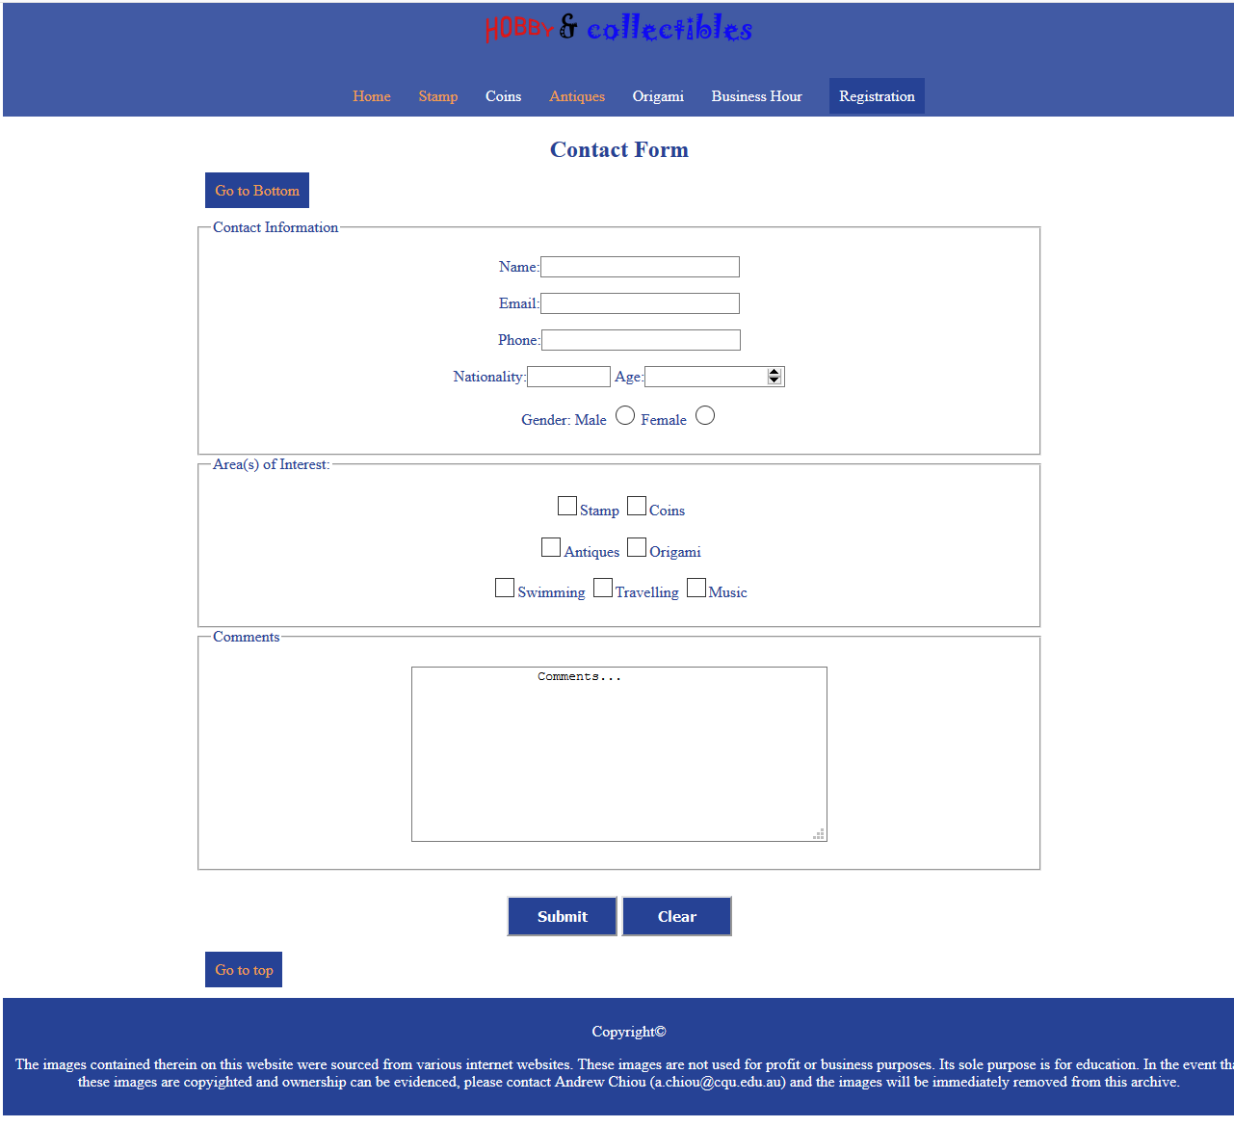

Fig:27 Form in large screen

**Form view in Mobile**

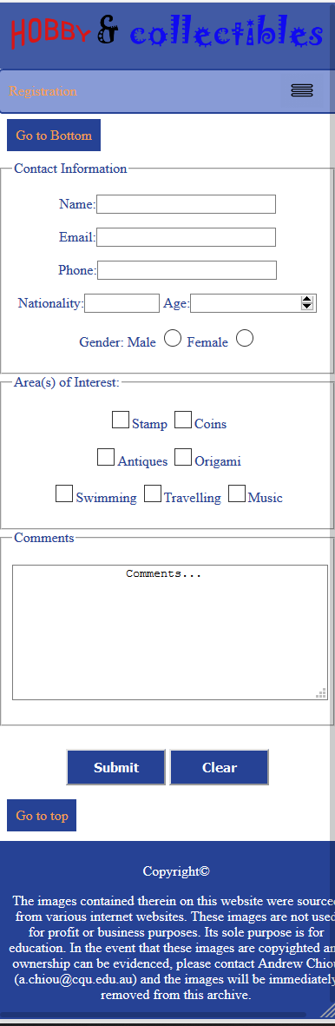  
Fig:28 Form in mobile view

**Horizontal mobile view**

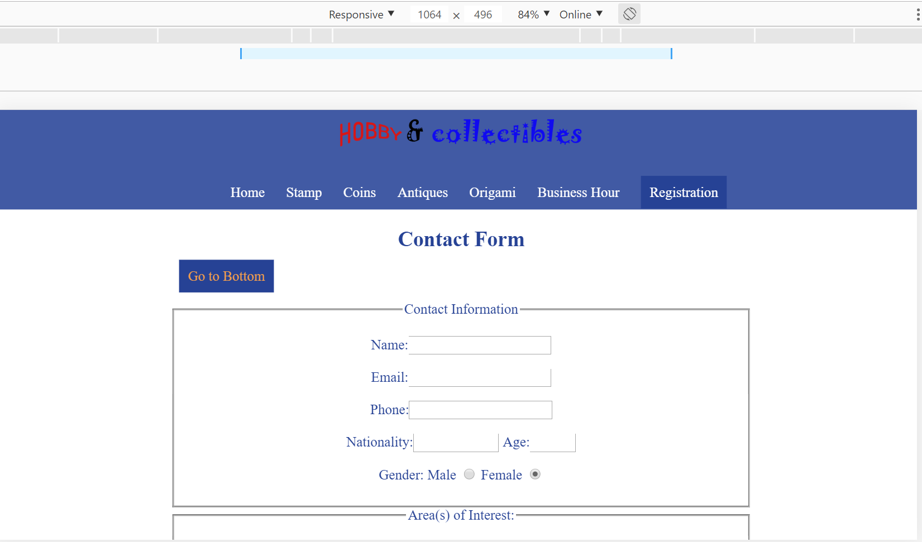

Fig:29 Form in mobile landscape view

# Portfolio 2.6

## Review and Testing

The website was tested and reviewed on multiple browser and devices. Mobile devices like iPhone 6,7,8, galaxy s9/s9+, kindle fire. Etc. were used to test the mobile view of the website. Firefox, internet explorer, google chrome were used test the desktop view of the website. The result shows that the website is compatible for most of the devices and browser. The links, navigation menu, colour and layout were properly displayed as expected.

3 people from different backgrounds were asked to provide the review of the website. The next section discusses about feedback provided by them.

**Bijay Rai:** According to him, the website is attractive, and the colour combination is appealing. He liked the website content section of the home page where there is welcome message and the floor plan. However, he told that in his laptop through google chrome, the website font is not consistent. He suggested to try different font family.

**Narendara karki:** He used his iphoneX to test the website through chrome. As per him, he liked the drop down menu and the presentation of the data through tables. He also liked the colour and clarity of the text in the webpages. He told that he didn’t find any functional issues in his browser. Overall, he felt the website is simple, informative and easy to use.

**Arjun Baniya:** He used dell laptop with Firefox browser to test the website. According to him, the website was great with proper layout organisation and easy navigation menu. He felt that the website has proper content prioritisation. He also liked the colour theme and clarity of the content in all the pages. However, he would like to have the search feature in the website.

## Assumptions

1. The flexible page layout of the website will allow any sized device to easily adopt on any browser.
2. The logo of the website will directly resemble the company Hobby and collection.
3. The vertical and horizontal responsive navigation menu will help user to navigate around the webpages
4. The floor plan image will map the physical layout of the shop.
5. By using the triadic colour combination, the visitors would find the legibility in the content of the website.

# Summary

Based on the principle of Responsive web design, the report identifies the core requirements of the website for Hobby’s and Collection. It identified the flexible layout in both standard large screen and mobile view. Colour graphics were picked out using the triadic pattern from colour theory. These colours were applied on various elements of the website like banners, tables, text, links etc. Navigation menu for both large screen and small screen were created using the flowchart. Business hour data were displayed using the table. Next, the form element will be used for collecting the basic information of the visitors. In addition, the site was tested and reviewed by 3 people in different machines to find any issues associated with legibility and communication. Overall, the report is successful in finding the best approaches in implementing the responsive design in the Hobby’s and Collection.